Create cloudfront for a failover website with s3 bucket and route53

Go to S3 and create primary and secondary buckets in different regions.

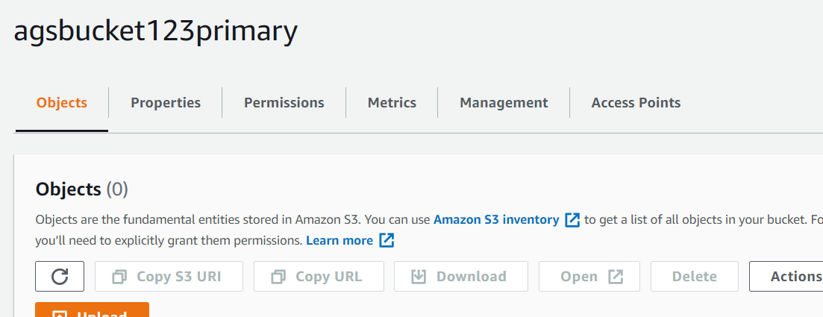

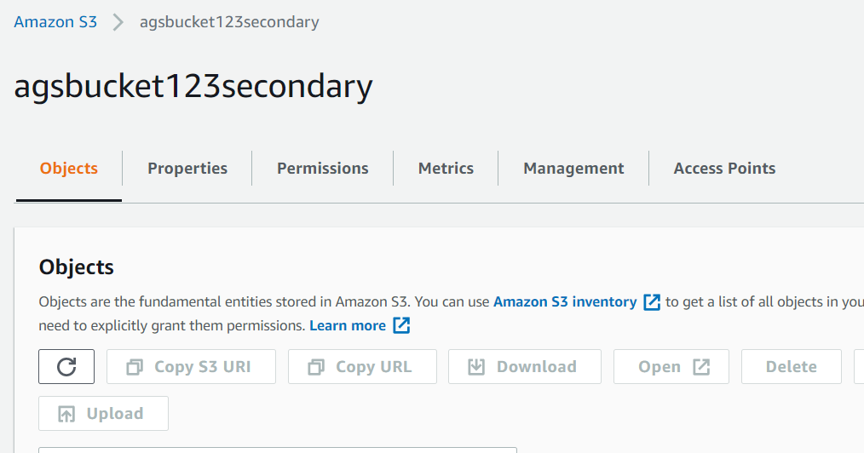

Now create a cloudfront distribution

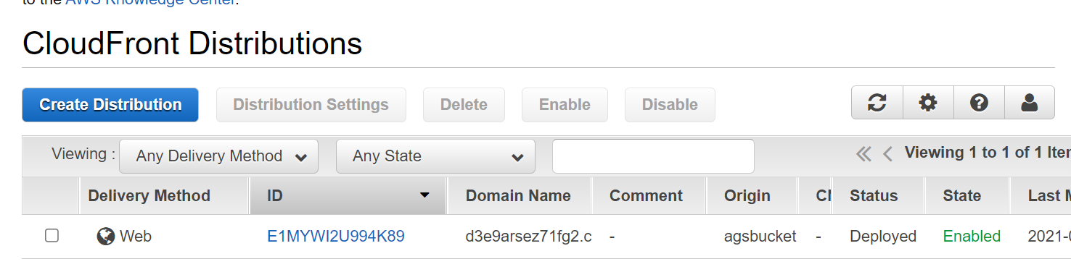

Now to to your s3 and upload objects

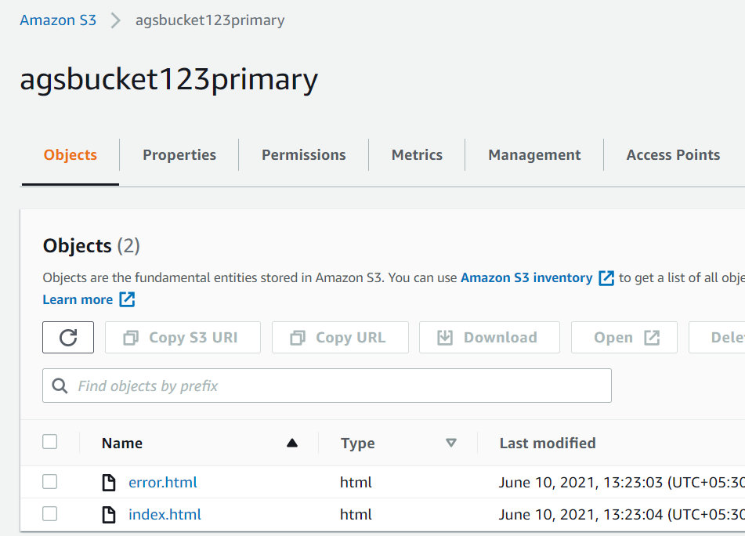

We will upload different content to secondary bucket.

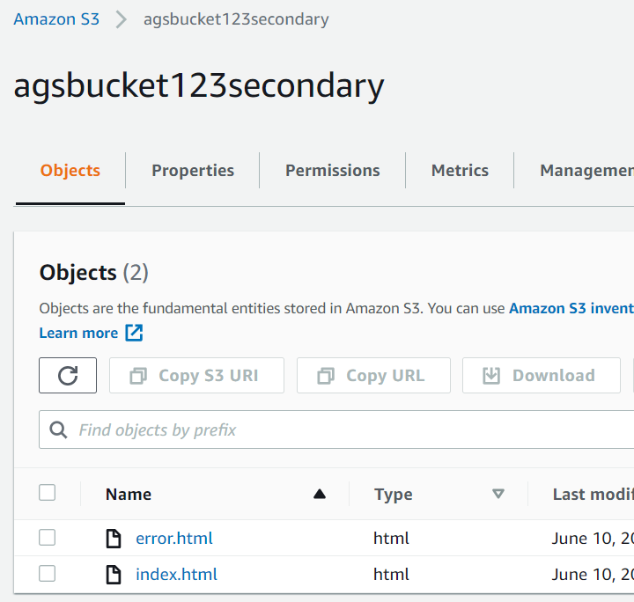

Remember second bucket should be public so that cloudfront can failover to it.

Attach the readonly policy to it

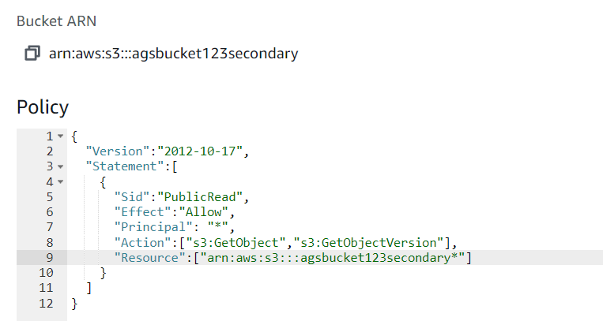

Now go to properties of the bucket

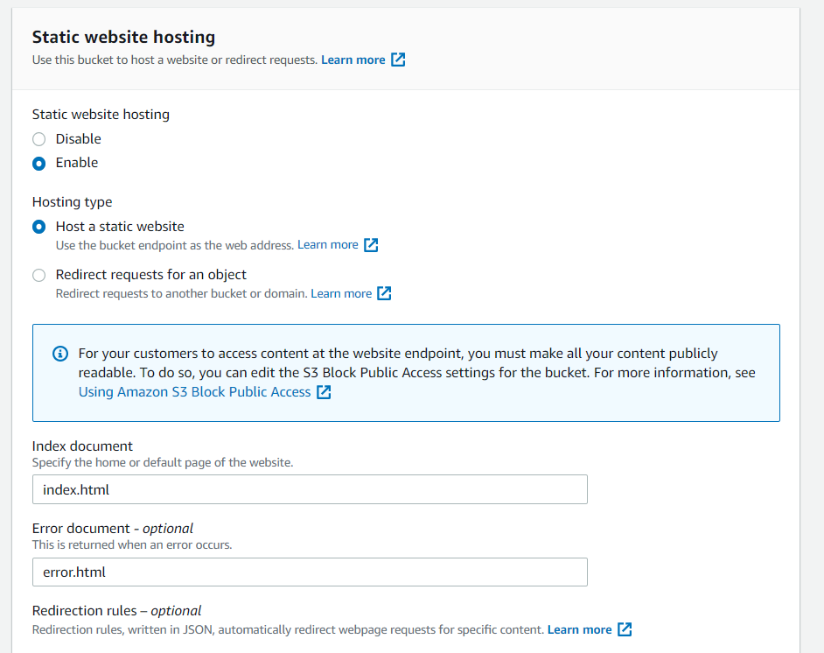

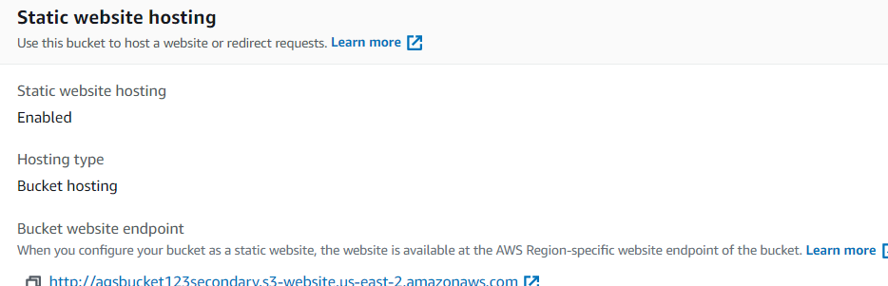



Open new tab



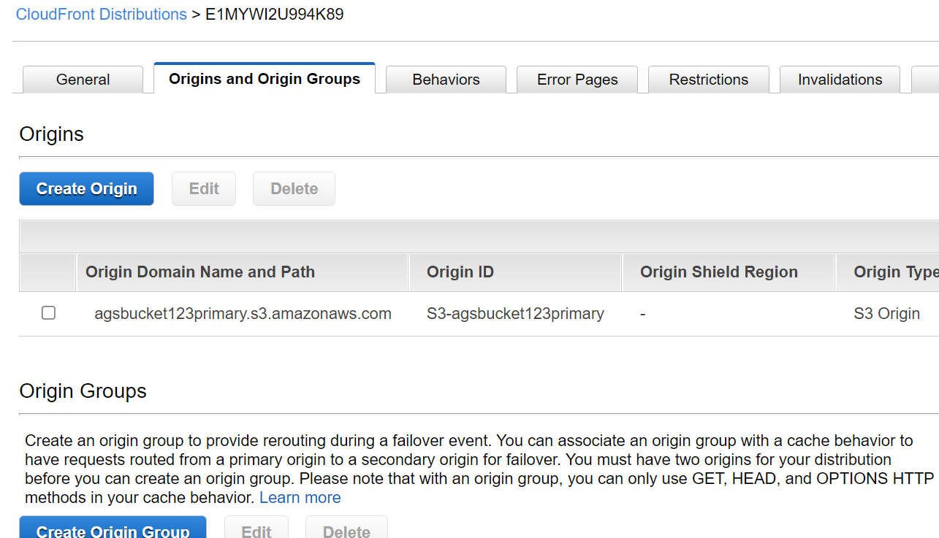

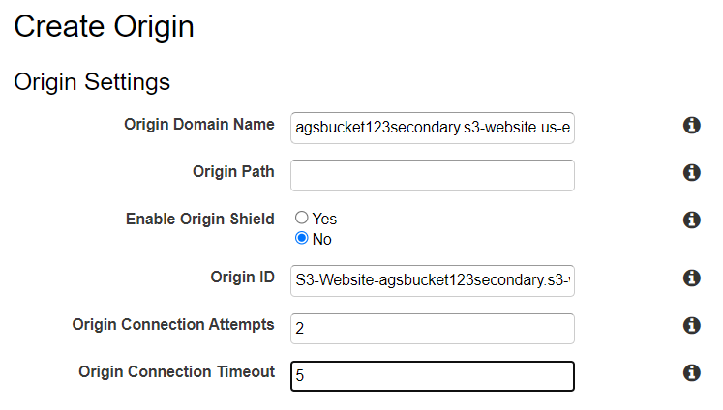

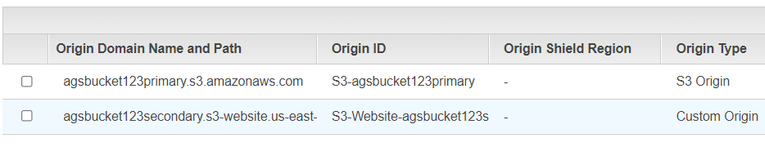

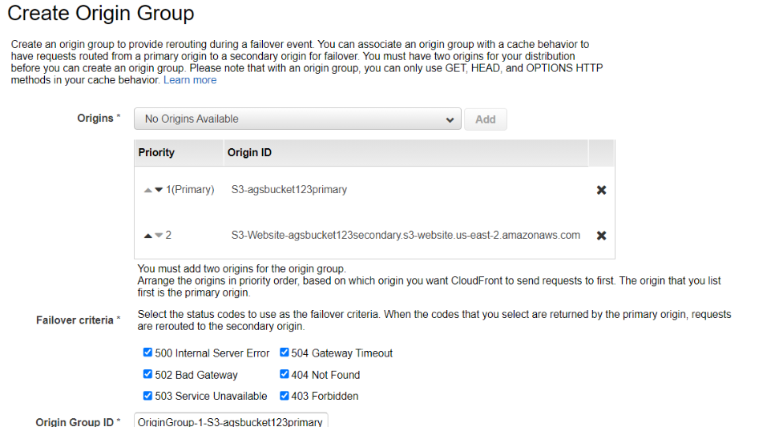

Now edit the behaviour

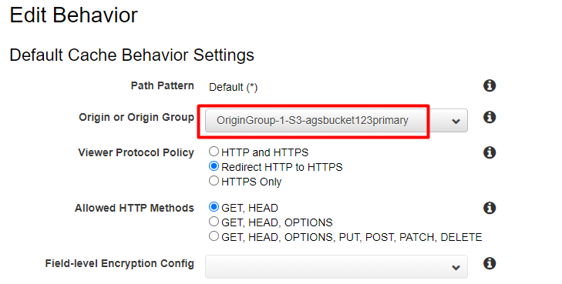

Now for failover go to s3 bucket primary and change index.html so that it can failover to

Change the file name

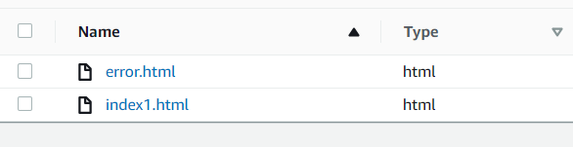

Create invalidation in cloudfront

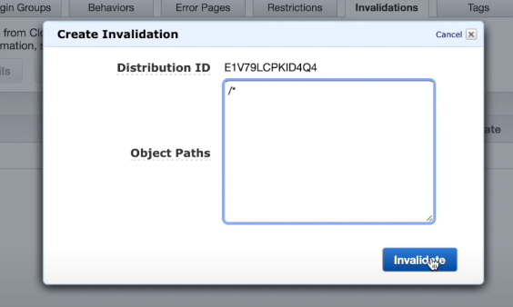

We fail to secondary bucket

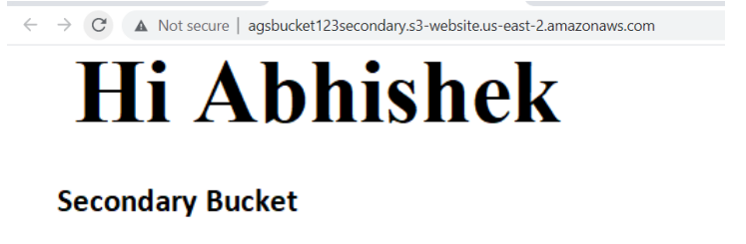

We can also remove the bucket policy from the s3, it will give 403 forbidden

Then the site will be forwarded to secondary/ failover s3 bucket.

